PHP Scheduler
The PHP Scheduler was created to improve the way we organize and execute the various scripts we currently have running in crontab. Instead of having scripts for each interval randomly placed within a crontab file, the Scheduler allows us to keep all scripts organized in an easy to use web interface. The Scheduler also grants us more flexibility by allowing us to execute scripts in intervals smaller than 1 minute unlike crontab which starts a series of scripts at the beginning of the minute and may overload the system.

- /ama/{phpprd|phptst}/scripts/ALL/{prd|tst}all_Sexecscripts.php (PHP5, SQLITE2, executed from command line)
This is a wrapper script which executes all scripts in all timeslots within an interval which is specified via command line argument.
  - Takes one argument of interval number. Ex: ‘/ama/{phpprd|phptst}/scripts/ALL/{prd|tst}all_Sexecscripts.php 1’ will run all scripts in all timeslots for the 1 minute interval.
  - Executes all scripts for each timeslot in chronological order. Sleeps in between each timeslot based on the value of set sleep time minus the elapsed time of scripts executed within the previous timeslot:
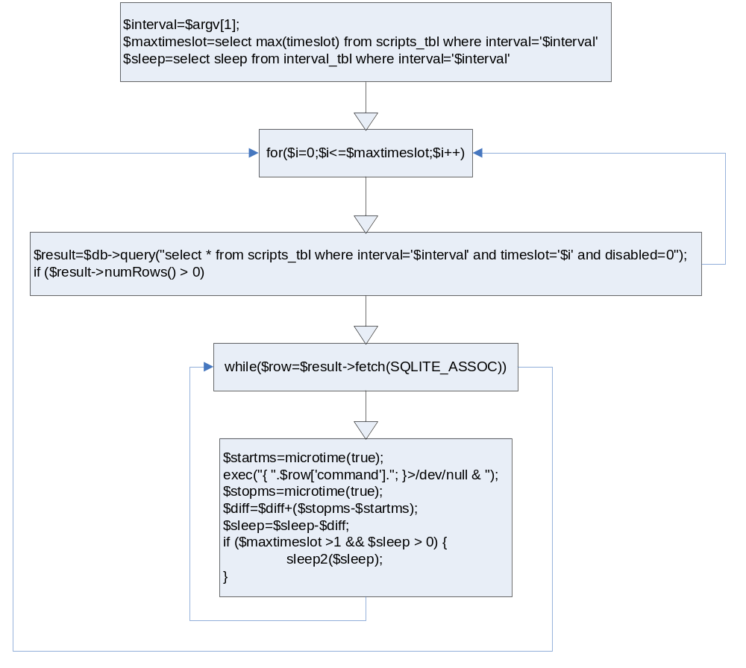
  - Logs information such as start/end times, timeslot number, script ID, and the commands which were run for each timeslot.
  - After executing scripts from all timeslots, all captured STDERR output is written to the error log along with start/end time of the execscript execution:
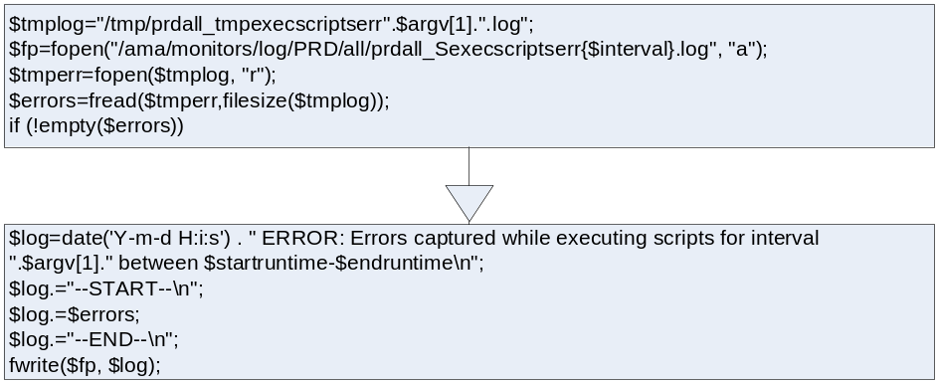

- The web app (Apache2, PHP5 w/ SQLITE2) http://php{prd|tst} /ALL/scheduler/
The web app was created to make it easier to import and modify scripts. The web application consists of two scripts, [prd|tst]all_Cscriptsadmin.php and [prd|tst]all_Cscriptsimport.php located in /ama/{phpprd|phptst}/www/monweb/ALL/scheduler/.
NOTE: Access is controlled via Basic Authentication. Each person has their own username and password.
- [prd|tst]all_Cscriptsadmin.php (PHP5, SQLITE2, java script)
  - Allows one to visualize the available intervals, the timeslots in each interval, and the scripts assigned to each timeslot, if any.
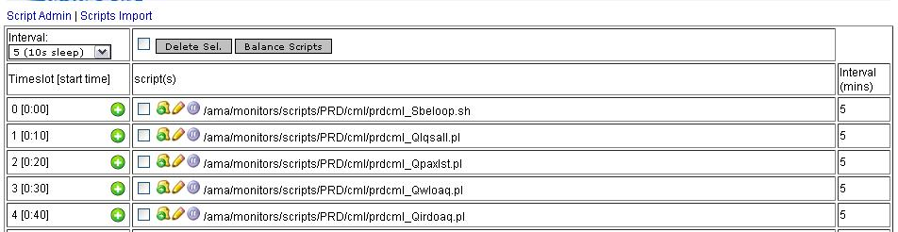

    - Timeslots are populated by first getting the amount of timeslots for a given interval which is done by dividing the interval value converted to seconds by the defined sleep time. Then scripts for each timeslot are populated by selecting all scripts assigned to each timeslot in the database:
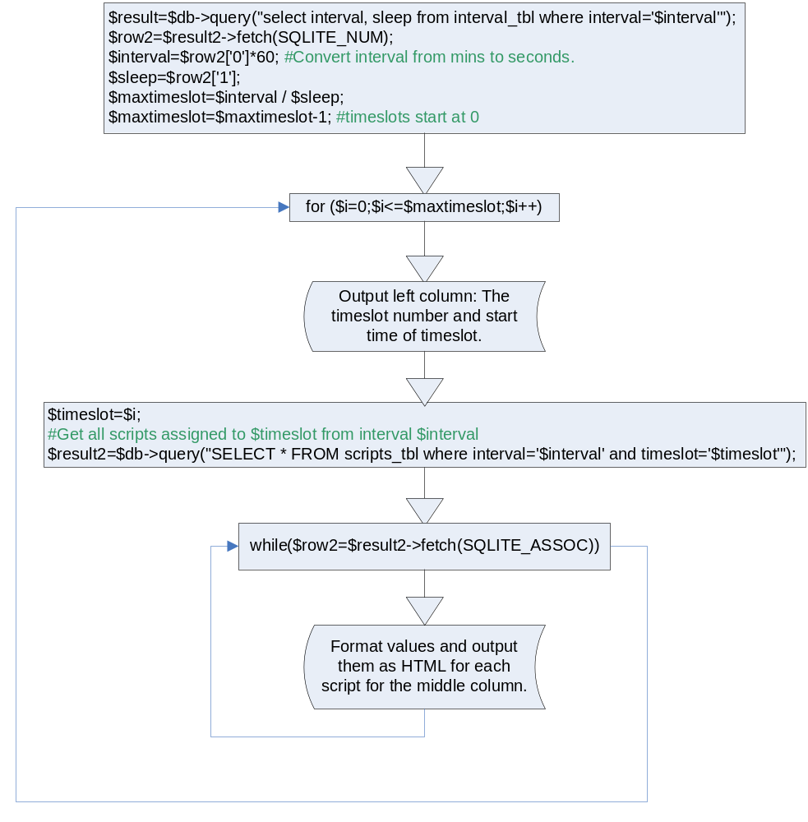
    - Timeslots with no scripts will be marked as “EMPTY”
    - Each script can be moved to different timeslots within the interval, edited, and deleted.
      - To move a script, click the icon next to the script, a prompt will pop up asking for timeslot to which you would like to move the script to. The value entered must be an integer and must not exceed the range of timeslots provided in parenthesis for example (0-29) for a 5 minute interval with 10 second sleep time:
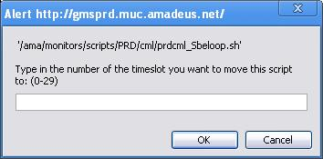

- To edit a script, click the icon next to the script, a prompt will pop up with the script contents in the textbox ready for you to edit. After to you are done editing and click OK, the edited script is run through the checkscript() function before an update is done on the DB.
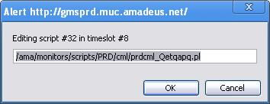
- To delete a script or several scripts, just check the checkbox next to the scripts you would like to delete and then click “Delete Sel.” button. The checkbox next to the “Delete Sel.” button will check off all scripts, and uncheck all scripts. This allows for easy mass deletion.

    - Scripts can also be balanced, meaning they are removed and then added back to each timeslot in order to maintain a balanced amount of scripts in each timeslot, if possible.
  - Addscripts.php (PHP5, SQLITE2, java script, must run via web)
  - Two options, create a new interval and import, or import into currently available intervals.
  - New: Allows one to create a new interval, with a desired sleep time in seconds, and import a massive amount of scripts.
    - Scripts are inserted into each timeslot in order. Once all timeslots are filled, the import starts importing scripts from the first timeslot again.
    - Current: Allows one to import a massive amount of scripts to the selected interval which already is defined in the DB. Optionally, scripts can be imported into a single timeslot instead of being partitioned amongst available ones.
    - Scripts are inserted into time slots selected by the least amount of scripts assigned to them, sorted by timeslot number in ascending order. This is done to keep a balance of the amount of scripts each timeslot has.
- /ama/{phpprd|phptst}/data/ALL/database/{prd|tst}all_scheduler.db (SQLITE2)
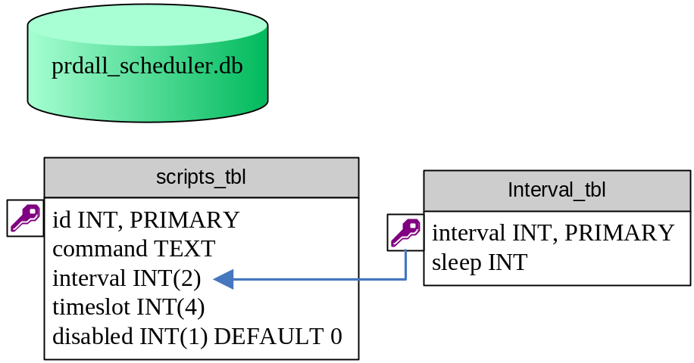
There are two tables in this DB: interval_tbl scripts_tbl
    - Schema for scripts_tbl:
create table 'scripts_tbl' (id INTEGER PRIMARY KEY, command TEXT, interval INT(2), timeslot INT(4), disabled INT(1) DEFAULT 0);
    - Schema for interval_tbl:
create table interval_tbl (interval INTEGER PRIMARY KEY, sleep INTEGER);
- Logging located in /ama/{phpprd|phptst}/log/{PRD|TST}/all/
  - Two logs for each interval
    - /ama/{phpprd|phptst}/log/{PRD|TST}/all/{prd|tst}all_Sexecscriptsinfo{$interval}.log:
Stores information such as elapsed time for each timeslot, which scripts were run, script id’s, and the start/end elapsed time for each execscript run.
Format:
YYYY-MM-DD HH:MM:SS INFO: Starting timeslot #[timeslot]
YYYY-MM-DD HH:MM:SS INFO: exec([script id]) [script command]
YYYY-MM-DD HH:MM:SS INFO: Ended timeslot #[timeslot] elapsed time: [duration of execution (secs)]

Example:
2008-10-17 18:55:02 INFO: Starting timeslot #0
2008-10-17 18:55:02 INFO: exec(155) /home/ocovtst/bin/resblock/resblock.pl
2008-10-17 18:55:02 INFO: Ended timeslot #0 elapsed time: 0.012042999267578

    - /ama/{phpprd|phptst}/log/{PRD|TST}/all/{prd|tst}all_Sexecscriptserr{$interval}.log
Stores any output from STDERR while executing scripts. Output is denoted by start and end time of the exec script.
Format:
YYYY-MM-DD HH:MM:SS ERROR: Errors captured while executing scripts for interval ${interval} between HH:MM:SS-HH:MM:SS
--START—
${STDERR}
--END—

Example:
2008-10-22 20:42:14 ERROR: Errors captured while executing scripts for interval 1 between 20:42:10-20:42:14
--START--
sh: test2: command not found
sh: test3: command not found
--END--

- DB backup & Log archiving

